Prague Congress Centre
třída 5. května 65
140 21 Prague 4
Czech Republic
Website: http://www.kcp.cz/en/homepage

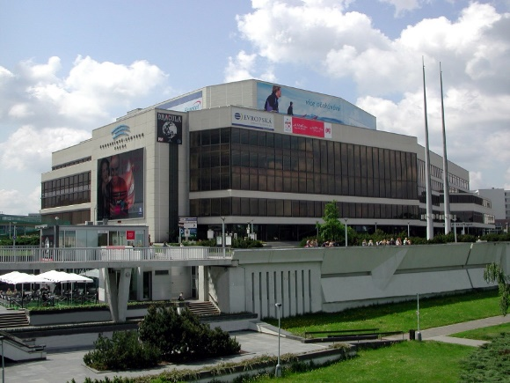

Prague Congress Centre is one of the dominant points of the City of Prague. It is located on one of Prague’s hills, which provides visitors with a beautiful view of the world famous Prague panorama where the silhouette of Prague Castle, together with a myriad of towers belonging to churches, cathedrals, palaces and ancient buildings from the historical centre, rise over the Vltava River and extensive parks.
The Prague Congress Centre is one of the largest and best-equipped European centres. Its range of conference, banquet and exhibition areas, including the assurance of accompanying services, makes it one of the largest and most comprehensive suppliers of these services and not only on the Czech market. The high technical quality, variability of internal areas and the exclusive view from the congress foyers and neighbouring halls makes this modern complex one of the most sought after congress localities. The fact that it is located in one of the most beautiful cities in Europe also undoubtedly contributes to this.
The pride of the Prague Congress Centre is the Congress Hall, which due to its excellent acoustics is one of the thirteen best concert halls in the world. Its parameters are comparable to London’s Royal Albert Hall, Montreal’s Salle Wilfrid-Pelletier and Boston’s Symphony Hall. Since 2000 Prague has been one of the world’s leading congress venues. The Prague Congress Centre has become one of the most modern centres in Europe and is the only facility of its type in the Czech Republic where it is possible to hold events for more than 9,300 participants, including areas for separate meetings of sections or groups.

