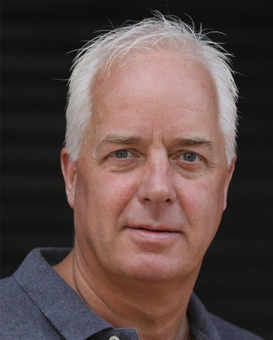  Prof. Hayden Spooner  Deputy Prime Minister for the Science, Research and Innovation | 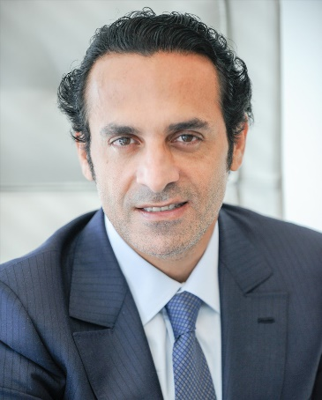  Ferdiando Piazza  Mayor of the City
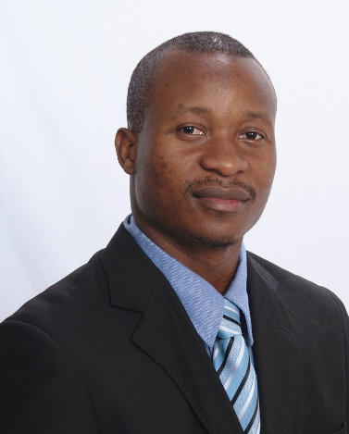  Dahlak Haile  President of the Academy of Sciences | 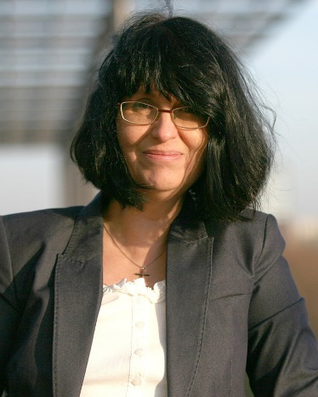  Pamela M. Corry  Rector of the Technical University

